SCREENSHOTS
Initial Safe State Output
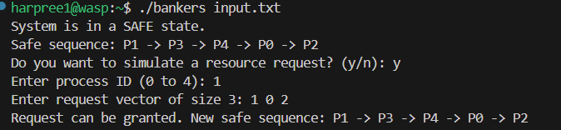
Request Exceeds Maximum Need
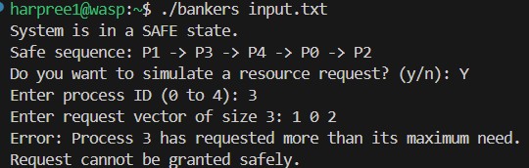
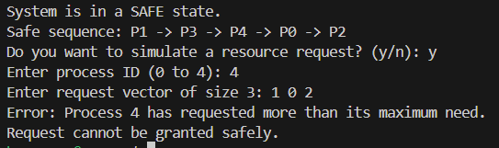
Unsafe Request Output
